Quality Plan

LSC Learning Management System

1. Introduction
This document, together with other referenced documents, defines the responsibilities and procedures to be adopted to ensure that the data and information produced as part of LSC Learning Management System are reliable, fit for purpose and consistent with documented objectives and deliverables. It summarises the system of internal management that governs the decisions and instructions concerning project quality assurance.

2. Project Contractual Information

Project: | LSC Learning Management System
Programme Co-ordinator: | Ms. Joan Limos  (LSC Admin)
Principal Investigators(s): | LSC Enrolment System Team  Name(s) and full details, i.e. address etc., of PI(s) with contractual responsibility

3. Scope of Work and Quality Objectives

Scope of work:  Quality Objectives: | The coverage of LSC Learning Management System is:  - Instructor can create and update course in classes.  - Instructor can add tasks such as quiz, exam or exercise in classes.  - Instructor can add announcements on calendar.  - Student can take tasks.  - Student can view their grades and attendance.  The LSC Learning Management system is only limited for the students of Loyola Student Center. This system will not cover the enrolment of the student; therefore, it is assumed that the student is already enrolled. Students who are enrolled will automatically have an account.  The following are the quality objectives of the LSC LMS:  - To provide the Loyola Student Center with a system for the learning management system and a database for their requirements.  - For faster administration of records of the task, grades and attendance of students in classes.  - For the administrator to announce updates faster and those announcements can see right away by the students in each class  - For the students of Loyola Student Center to have easier access on their progress online.
QA Requirement:

4. Project Organisation

Project Manager(s): | Jana Marie Gavarra Gardon  Name and position of senior management having overall responsibility for the project and management and nominated deputy
Task Manager(s): | Ms. Roselle Wednesday Gardon  (Project Adviser)
Quality Assurance: | Jana Marie Gardon  (Project Manager)  Name and position of person responsible for QA and nominated deputy
Other Team Members: | Johanna Marisse Credito Heramia  Jose Lorenzo Gonzales Tadeo  Names and titles of all other team members (technical and administrative) and a description of their duties
Technical Reviews: | Mr. Francis Uñalivia  (Database consultant)  Mr. Jojo Castillo  (Project consultant)  Mr. Justin Pineda  (System security consultant)  Mr. Allan Cotecson  (Project consultant)  Names of staff responsible for technical review (checking and approval) of procedures, deliverables, etc.

5. Project Duration and Scheduling

Start Date: | June 13, 2016
Completion Date: | December 14, 2016
Scheduling of Activities: | Scheduling the activities through Gantt Chart that is used to clarify complex scheduling; any milestone or hold points were identified. Duration of time for the specific milestone were determined and the percent complete indication that has a big help to managed the project efficiently. This shows what has to be done and when it should start and finish.
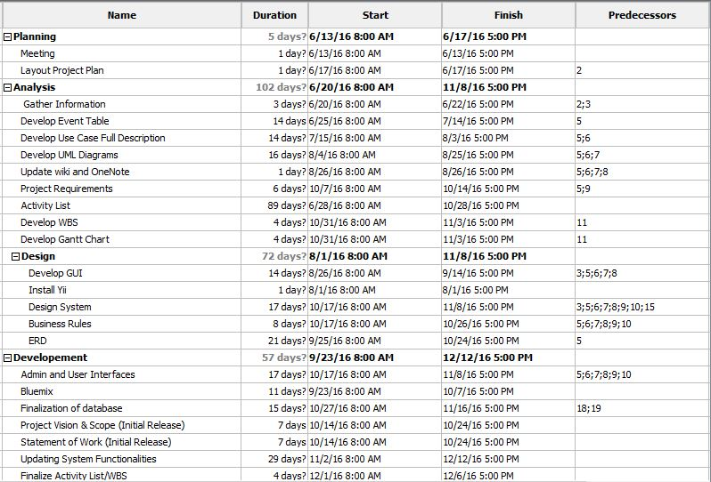

6. Deliverables
Deliverables specified for the project include:

- An acceptable Quality Plan
- An acceptable Change Management Plan (Appendix YY)
- An acceptable Software Requirement Specification
- An acceptable Scope of Work
- An acceptable Project Vision and Scope
- Progress Reports
- User Manual
- Final Paper

7. Review of Quality Plan
The Quality Plan will be reviewed every consortium meeting to keep the information produced as reliable, fit for the purpose, consistent with the objectives and deliverables and within the project scope.

Specify how and how often this Quality Plan will be reviewed, e.g. every three months at consortium meetings

8. Document and Record Control
Project documents, records and data will be controlled and stored in GitHub (www.github.com), which is a web-based repository hosting service that offers all the distributed version control and Projects Wiki (www.projects2.apc.edu.ph/wiki) by Jana Gardon, Johanna Heramia and Renzo Tadeo. It will be clearly labelled and made available for consultation by all members of the project team.
The Quality Plan, Project Vision and Scope, Scope of Work, Software Requirement Specification and Change Management Plan will be issued to all members the team.
Project Progress Report will be issued to the professor.

9. Documented Procedures
Give the references of any in-house and/or published methods or procedures used during the project. References need not include the issue/version number, providing that staff are informed separately of modifications to Procedures. Otherwise, provide a basic resume of methodology with an indication of how it will be archived for future reference. Any centrally administered documents that relate to quality assurance should also be referenced.

10. Additional Information
Unless included in associated technical procedures, any other information that has direct relevance to the quality of the product or service being provided should be included in the Quality Plan. This could include [add or delete as necessary]:
- All deliverable or other documents are based on the client’s request. The document will be reviewed by the professor, project adviser and client as well.
The additional procedures and controls for the review and verification of deliverables or other documents;
- LSC Learning Management System is made and can only be accessed by LSC employee and students only as long as they have an account. The system requires an internet connection to be accessed. The account for student is different from the client side. The student side has no access on editing the content of their account while admin can add, view or delete information.
Special requirements for the identification and traceability of products, including, where applicable, the traceability of staff performing specific duties;
- In identifying the status of inspection and test products, the clients or the developers can depend on the deliverables.
Special criteria for identifying the status of inspection and test products;
- The LSC Learning Management System is a user friendly system but the deliverables like User manual can help the employee to have easier access of the system.
Minimum qualifications, training or experience required of staff to undertake certain activities, or any specialist staff training;
- The employee, either admin or instructor monitors and update the content of the system however, some technical issues are to be updated by the project developers.

Process control requirements, including monitoring of activities;
- The information are store in a database powered by MySQL.
Special procedures for the handling, storage, packaging, preservation and delivery of product;

Prepared by: Date:
Jana Marie Gardon

Checked by: Date:
Johanna Marisse Heramia

Approved by: Date:
Jose Lorenzo Tadeo

